HTML-CSS PRACTICE 03

1. Let’s complete the simple layout below

Resource in “layout”

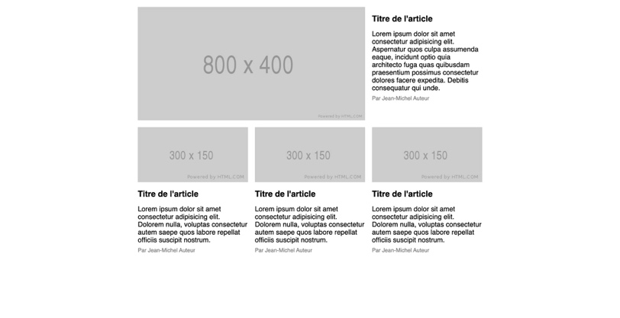

1. Create a menu that fixed 3 generation as all images bellow

Resource in “menu”

- State 1: fold menu (not hover to any item)



- State 2: hover to an item



- State 3: hover to child menu, show child menu

